Lasse Dörjer (1583997)  
Ich habe diese Übung einmalig allein bearbeitet, da ich dem Zeitpunkt noch keinen Partner hatte.



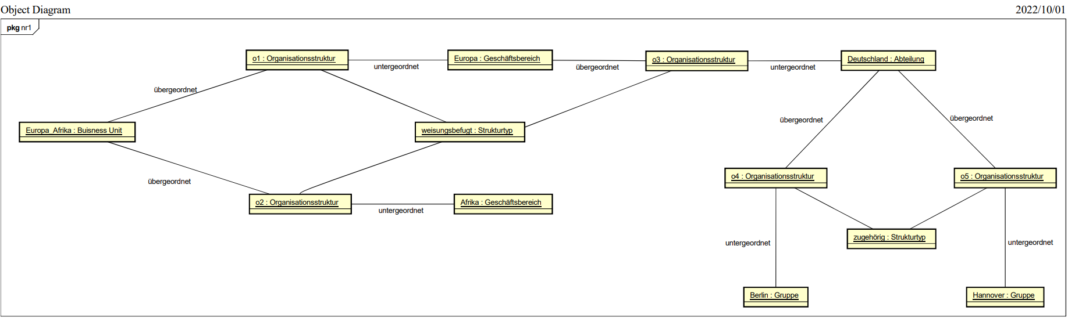

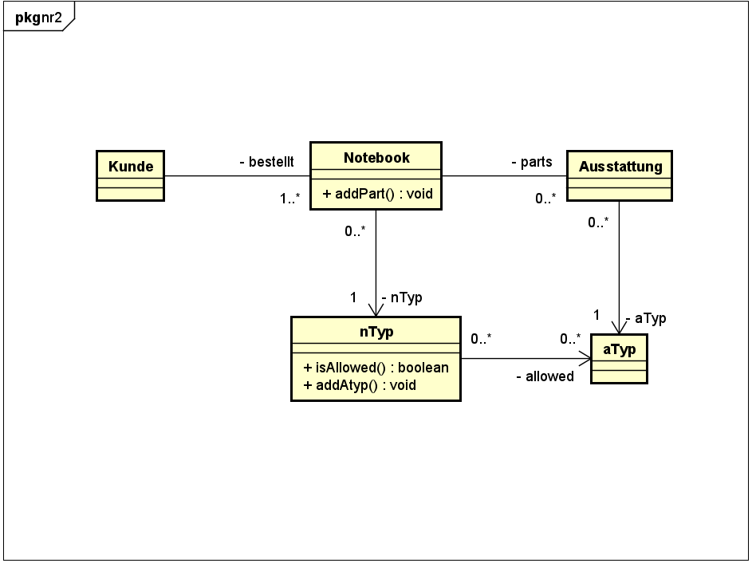



public class prog {  
 public static void main(String[] args) {  
 aType at1 = new aType("Thinkpad Docking Station");  
  
 nType nt1 = new nType("ThnikPad");  
 nType nt2 = new nType("Apple MacBook");  
  
 Austattung as1 = new Austattung("aus1", at1);  
  
 Notebook nb1 = new Notebook("nb1" , nt1);  
 Notebook nb2 = new Notebook("nb2", nt2);  
  
 nt1.addAllowed(at1);  
  
 System.out.println(nb1.addPart(as1));  
 System.out.println(nb2.addPart(as1));  
 }  
}

public class Notebook {  
 private ArrayList<Austattung> parts = null;  
 private String name;  
 private nType nType;  
  
 public Notebook(String name, nr3.nType nType) {  
 parts = new ArrayList<Austattung>();  
 this.name = name;  
 this.nType = nType;  
 }  
  
 public boolean addPart(Austattung part) {  
 if (this.getnType().isAllowed(part.getaType())) {  
 this.parts.add(part);  
 return true;  
 } else {  
 return false;  
 }  
 }  
  
 public ArrayList<Austattung> getParts() {  
 return parts;  
 }  
 public String getName() {  
 return name;  
 }  
 public void setName(String name) {  
 this.name = name;  
 }  
 public nr3.nType getnType() {  
 return nType;  
 }  
 public void setnType(nr3.nType nType) {  
 this.nType = nType;  
 }  
}

public class nType {  
 private String name;  
 private ArrayList<aType> allowed = null;  
  
 public nType(String name) {  
 allowed = new ArrayList<aType>();  
 this.name = name;  
 }  
  
 public boolean isAllowed(aType aType) {  
 return this.allowed.contains(aType);  
 }  
  
 public void addAllowed(aType allowed) {  
 this.allowed.add(allowed);  
 }  
  
 public ArrayList<aType> getAllowed() {  
 return allowed;  
 }  
 public String getName() {  
 return name;  
 }  
 public void setName(String name) {  
 this.name = name;  
 }  
}

public class Austattung {  
 private String name;  
 private aType aType;  
  
 public Austattung(String name, nr3.aType aType) {  
 this.name = name;  
 this.aType = aType;  
 }  
  
 public String getName() {  
 return name;  
 }  
 public void setName(String name) {  
 this.name = name;  
 }  
 public nr3.aType getaType() {  
 return aType;  
 }  
 public void setaType(nr3.aType aType) {  
 this.aType = aType;  
 }  
}

public class aType {  
 private String name;  
  
 public aType(String name) {  
 this.name = name;  
 }  
}